School of Medicine Equipment Transfer User Documentation
After entering the equipment into the online asset disposition tool complete the online SOM equipment transfer request form by following the steps below (#1-4). Enter the same equipment list into each of the forms.

- Create a new request.

- Requesting Section: Click on the respective book icon to enter the PI, Business Manager, Business Manager Designee, and Chair, Center or Institute Director.
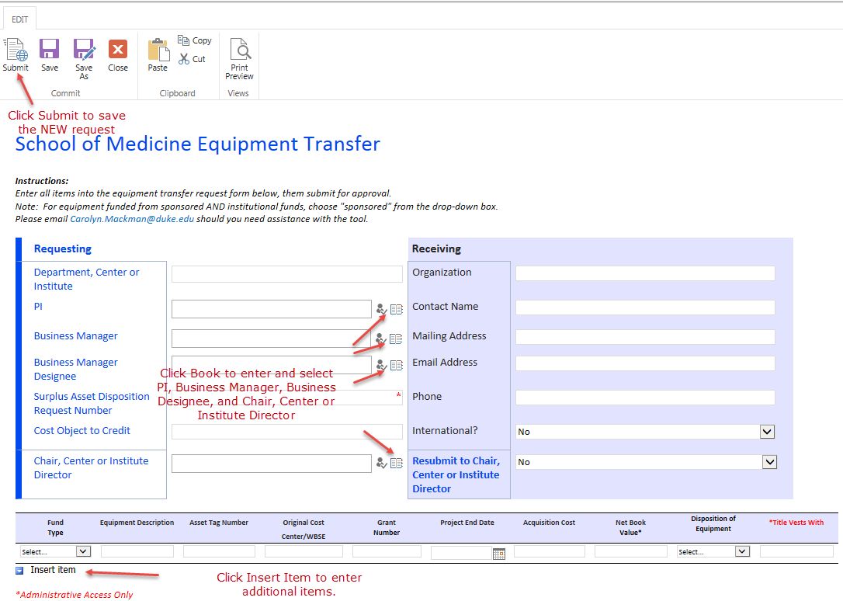
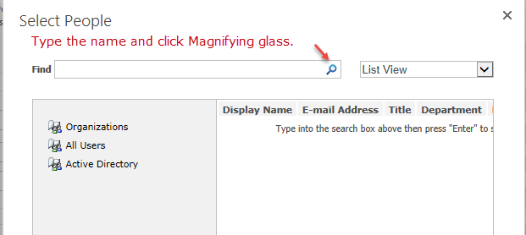
The name is inserted into the form.

- Receiving Section: Complete with receiving institution contact information.

- Add all equipment that is being requested for transfer using the drop down options as appropriate.

- After the list is complete click the “Submit” icon.
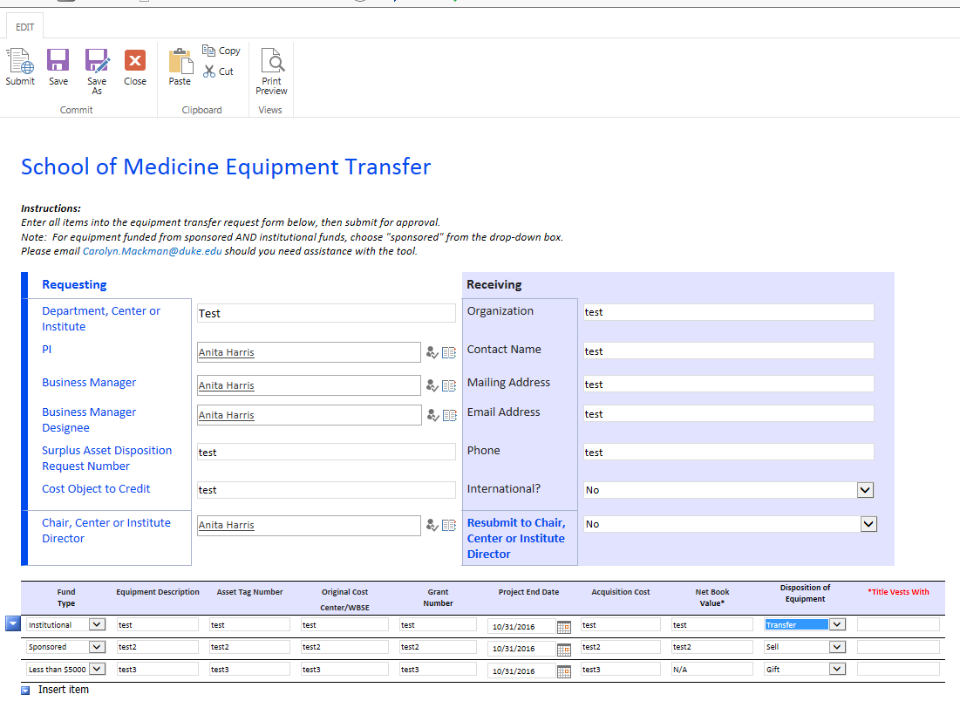

- Approval Process
- Upon submission, the Chair, Center or Institute Director will receive the following email entitled:
Action Required: SOM Equipment Transfer Request. (Note: upon submission the PI will also receive an email with view only access to the equipment transfer request form.)
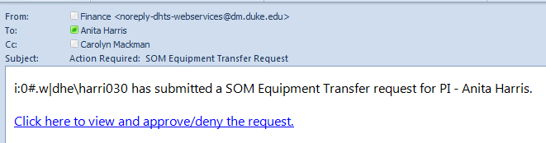

- Click the link in the email opening the My Documents view. Then click the name of the document (which is a link) to open the form.
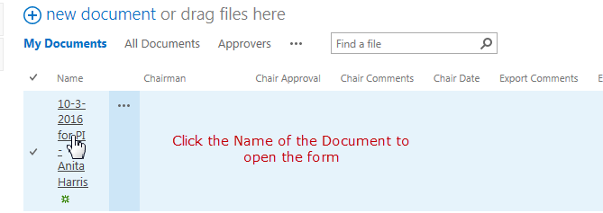

- The Chair, Center or Institute Director must select an approval type. If desired a comment may be entered, this may be more pertinent if the request is being denied (see next note). Once the approval type is chosen the Chair or Director must click “Save” and then “Close” in the ribbon at the top of the form. If “request approved” is chosen, the form will be automatically forwarded to the next unit for approval.

- If the Chair, Center or Institute Director denies the request, the requestor and the PI will receive the following email:
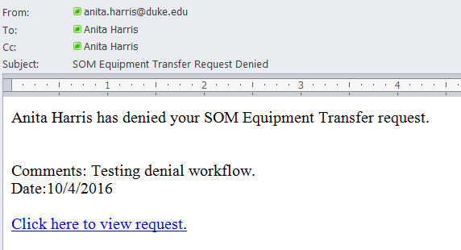

- Correcting and Resubmitting Request
- Dependent on the denial reason, the information on the form may be edited and then resubmitted to the Chair, Center or Institute Director. The requestor would correct the information and then select “Yes” for “Resubmit to Chair, Center or Institute Director”. Then click “Save” and “Close”. The Chair, Center or Institute Director is sent the request for review.
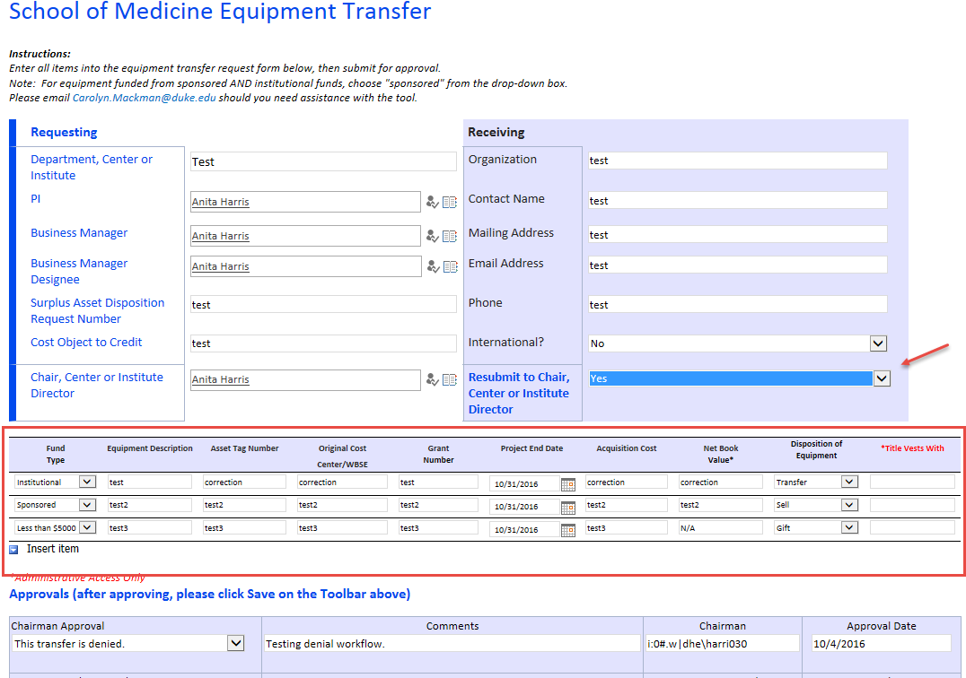

- International Transfer Requests
- If the request involves transfer of the equipment to an international destination, the request is sent to Export Control after the Chair, Center or Institute Director approves. If Export Control denies the request, the following email is sent to the requestor and the PI is copied:
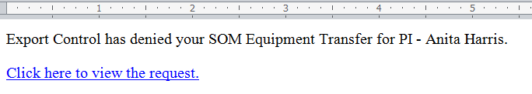

- Completion
After all approvals are in place, the PI, Business Manager, Business Manager Designee, and PI receive an email with a link to the My Documents view.
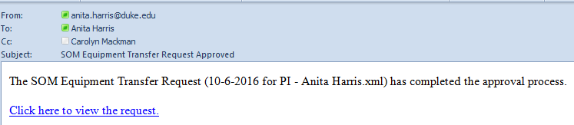
And the Procurement Office will send a liability release form/invoice to the department to forward to the receiving instutuion for signature/payment. Once the form/funds have been received by Duke the department notifies the Procurement Office and releases the equipment for transfer.
Please reference SOM Equipment Transfer Policy for more details.

